Bitwarden BC/DR Plan
Joseph Arnoldo, Zachary Hopping, Bradley Chavis, Matt Graham
University of Advancing Technology

Bitwarden BC/DR

Table of Contents

Bitwarden BC/DR 2
Table of Contents 2
Asset Inventory 3
Assets 3
Vendors 4
Risks 5
Natural Risks 5
Man-made Risks 7
IT & Technology-based Risks 9
Risks Defined by FEMA 11
Loss of Business-Critical Functions Analysis 14
Risk Mitigation 17
Backups 19
Hot Site 19
Cold Site 20
Snapshots 21
Redundancy 22
Downtime Procedure 23
BC/DR Guide 25
BC/DR Activation Steps 25
BC/DR Plan Maintenance 26
Contacts 28
Response Teams 28
Insurance Provider 28

Asset Inventory

Assets
- Employee endpoints
- GitHub code repositories
  - server
  - help
  - browser
  - jslib
  - web
  - mobile
  - cli
  - desktop
  - directory-connector
  - brand
  - docs
- Azure databases
  - Payments
  - Authentication
  - Vaults
- Azure VM instances
  - Identity Service
  - RESTful API
  - Web Vault
- Azure snapshots
- Azure Blob storages
  - BC/DR Plan

Vendors
- Azure
- GitHub
- Paypal
- Stripe
- Google Analytics
- Cloudflare
- Freshchat
- Insight Risk Consulting (used in 2020 for external pentesting)
- Cure+53 (used in 2018 for external pentesting)

Risks
For defining the risks, we used the following location: West US, Fresno California. This is the closest Azure datacenter located near Bitwarden’s headquarters and is being used since the headquarters for Bitwarden does not get utilized as all employees work remotely.

Natural Risks
Hazard | Sources | Likelihood (0 to 10) | Assess Impact
Avalanche | Humans, Earthquakes | 1 | Low - If an avalanche were to occur, there would be minimal impact on Bitwarden operations
Severe snow | Weather, Natural | 1 | Low - Would affect employees if traveling, most likely would not affect the datacenter
Ice storm and hail storm | Weather, Natural | 1 | Low - Most likely no effect on datacenter, though could affect employee’s travel
Severe or prolonged wind | Weather, Natural | 3 | Medium - Would not affect the datacenter directly, instead another critical resource such as power
Severe or prolonged rain | Weather, Natural | 5 | Medium - Would not affect the datacenter directly, instead another critical resource such as power
Heavy rain and/or flooding | Weather, Natural | 5 | High - Flooding would cause damage to Azure datacenter infrastructure
Drought | Weather, Natural | 8 | None - Would not affect the operations of the datacenter
Fire | Human, Weather | 3 | High - Critical infrastructure may get severely damaged to no repair
Tropical storms | Weather, Natural | 0 | None - No tropical storm could occur
Hurricanes, cyclones, and typhoons | Weather, Natural | 0 | None - No hurricane could occur
Tornados | Weather, Natural | 1 | Medium to High - Depending on the force, building and technology damage would be imminent
Wind storm | Weather, Natural | 4 | Medium - Would not affect the datacenter directly, instead another critical resource such as power
Earthquake | Geographic, Natural | 5 | Medium to High - Assuming the earthquake that occurred was large enough to be felt, some damage may occur to the datacenter building and assets
Tsunami | Weather, Natural | 1 | High - Although it’s unlikely that a tsunami would hit the datacenter that far away from a water source, it would seriously affect the building’s structure and technology inside
Volcanic eruption | Weather, Natural | 1 | Medium - If lava were to somehow reach the datacenter, serious damage to the building could occur
Landslide | Geographic, Natural | 3 | Low - Would cause some, but not critical damage to the datacenter’s building
Land shifting | Geographic, Natural | 2 | Medium - Could cause structural damage, leading to a disruption in operations

Man-made Risks
Hazard | Sources | Likelihood | Assess Impact
Bombs | Human | 1 | High - If a bomb were to go off, the building, servers, and lots more would be damaged to no repair, along with all the associated deaths
Armed attacks | Human | 1 | Low to Medium - Although it would be a very sad moment as people may die, critical systems likely would not go down
Hazardous material release | Human | 1 | Medium to High - If hazardous material would be released near or within the Azure datacenter, nobody without proper gear would be allowed back in. In this event, if a piece of equipment were to fail, it would not be able to be fixed right away
Cyberattack | Human, Nation-State | 4 | Critical - If a successful attack were to occur, operations would be halted
Transportation attack | Human | 1 | Low - Would only affect employees travelling to the datacenter
Infrastructure attack | Human | 2 | High - If successful, critical resources may go down
Kidnapping | Human | 2 | None - Would not affect operations
Explosion | Human | 1 | High - If large enough, major damage could be done inside and outside of the datacter
Civil disorder, rioting, and unrest | Human, Political | 2 | Low - If a riot were to occur that was directly against the datacenter, operation would still be able to continue with some precaution
Protests | Human, Political | 3 | None - Would not affect operations
Product tampering | Human | 1 | High - This would make a supply chain attack, affecting hundreds of thousands of people and causing a halt in operations
Radioactive contamination | Human | 1 | Critical - Indefinite time to return safely, systems could not me maintained or upgraded
Embezzlement, larceny, and theft | Human | 1 | None - Would not affect operations
Extortion | Human | 2 | Medium to High - If the right employee was targeted, the CIA triad could be compromised
Subsidence (shifting of land causing building or infrastructure failure) | Geographic, Weather | 3 | Low to High - Would highly depend on the amount of shifting, but could cause very large structure damage, and therefore a chain reaction

IT & Technology-based Risks
Hazard | Sources | Likelihood | Assess Impact
Power grid or substation failure | Service provider, Human | 2 | High - If the backup power sources were to fail as well, all operations would be halted
Major service provider outage | Service provider | 2 | High - If down for long enough, critical assets may not be accessible until the service comes back up
Communication infrastructure outage (undersea cables, satellites, etc.) | Service provider, Human | 1 | Medium - Operations would still be able to continue in the US, but be disrupted everywhere else
Internet infrastructure outage | Service provider | 2 | High - If all of the ISPs went down at once, all operations would be halted
Computational hardware failure | Product | 3 | Low - Redundancy in systems
Networking hardware failure | Product | 3 | Low - Redundancy in networking systems
Storage hardware failure | Product | 5 | Low - Redundancy in storage systems
Endpoint Device Network Attack | Hacker | 2 | Low - Although damaging, Bitwarden would not be affected unless their systems were targeted
Physical Security Attack | Hacker, Employee | 1 | Low - Although damaging, Bitwarden would not be affected unless their systems were targeted
EMP | Electromagnetic Pulse, Solar flare | 1 | Critical - Lots of unfixable damage would occur, and disrupt operations for a long while

Risks Defined by FEMA
For the following risks, Bitwarden’s headquarters was used since an exact address for Azure’s West US datacenter is not publicly available.

Flooding
Moderate - located near a body of water, without a base flood elevation, and the only protection is elevated land (11.32 to 13-foot range), though is near a regulatory floodway.
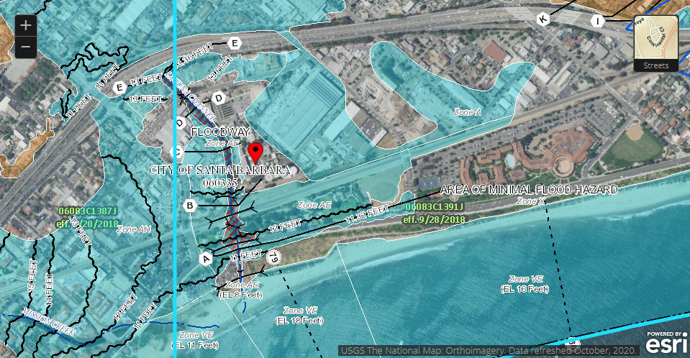

Earthquakes
High - located in an area close to a major active fault line capable of producing the most intense shaking. Damage could include structure frames being broken, particle collapses, shifted building, or complete destruction.
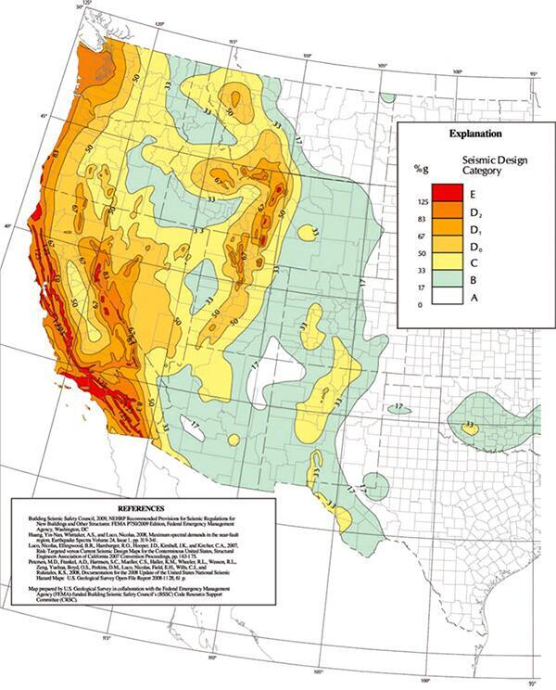

Fire
High - between 2008 and 2017, 6,915 incidents of fire were reported to NFIRS. Most were caused due to cooking, however, a good percentage relates to things that may affect Bitwarden’s operations, such as an electrical malfunction in Azure’s Datacenter.
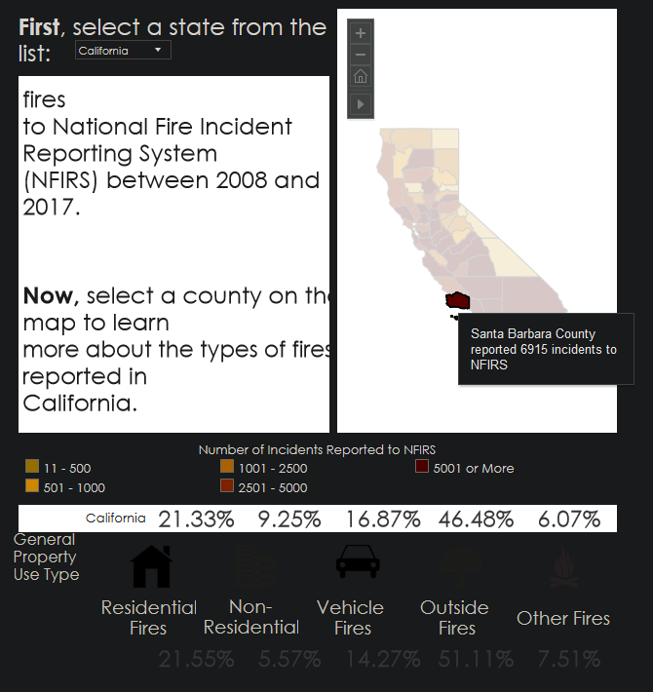
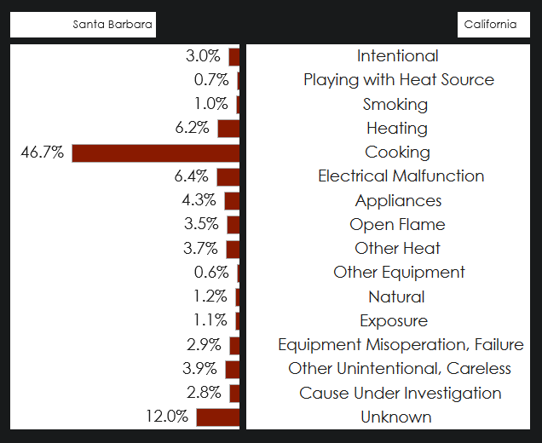

Loss of Business-Critical Functions Analysis

Function | Business Priority (1-10) | Threat Source | Impacts | Maximum Tolerable Downtime | Financial Impact | Dependencies | Work  Around
Internal Communication | 3 | Power outage, Internet outage, Cyber attack | Employees | 5 Hours | Low - Operations can still occur, and there are other platforms of communication that could be utilized. | Slack, Google, Microsoft, etc. | Another communication platform (e.g., email).
Access to Code Repository | 3 | Power outage, Internet outage, Cyber attack | Employees, Customers | 3 Hours | Low - Although it would affect the development, many of the developers likely will have local backups to work off of. | Github/Microsoft | Utilize a local repository.
Provide Identity Service | 10 | Power outage, Internet outage, Cyber Attack | Customers | 1 Hour | High - If the Identity Service goes down, so does all of customer-based Bitwarden operations. | Azure | None.
Provide RESTful API | 10 | Power outage, Internet outage, Cyber Attack | Customers | 1 Hour | High - If the RESTful API goes down, so does all of customer-based Bitwarden operations. | Azure | None.
Provide Web Vault | 8 | Power outage, Internet outage, Cyber Attack | Customers | 2 Hours | High - If the Web Vault goes down, Bitwarden can still be utilized, but it would only be limited to extensions, local applications, and mobile applications. | Azure | None.
Provide Payment Options | 9 | Power outage, Internet outage, Cyber Attack | Customers | 30 Minutes | Critical - Customers would not be able to purchase a subscription, but would still be able to access their vault | Paypal, Stripe | Use another payment processor.
Physical Server Integrity | 8 | Server Room Environment, Physical Attack | Employees, Customers | 1 Hour | Medium to High - If the server were to fail, it could affect customers and employees until it was brought back up or a backup came online. | Azure | Utilize a redundant server/availability zones.
Provide a Workforce | 10 | Illness, Personal Issues, Workplace Environment, Work Inefficiency, Disgruntled Employee | Employees, Customers | 24 Hours | Low to Medium - We need employees, though if only a couple employees are missing, it will not affect business operations | None. | Have on-call personal.

Risk Mitigation
Function | Recovery Specification | Risk Mitigation | Estimated Time to Recovery | Cost | Feasibility | Service Level Agreement
Internal Communication | Allow employees to communicate with each other across all platforms with no downsides. | Create a redundant, local-hosted communication platform similar to the one already being used. Or, have communication set up on a highly-available platform for a backup. | 5 to 15 minutes | $1,500/$0 | Medium/High | 97% Uptime
Provide Connectivity to Servers | Have operations continue as normal, without anyone being able to notice. | Host a redundant, hot spare server on another Azure datacenter region. | 0 minutes | About $500 per month | Extremely High | 99.9% Uptime
Access to Code Repository | Code can be pulled, pushed, committed, and controlled via version management. | Host a local version management platform, having it pull Bitwarden’s source code at a predefined interval (e.g., 1 hour). | 5 minutes | $3,000 per year, plus $2,000 for initial setup | High | 99% Uptime
Providing Support | Support can occur like normal, helping customers within the predefined SLA. | Utilizing another email service for the time being. | 2 hours - source code on Bitwarden’s website would need to be changed | Free | High | 94% Uptime
Providing Backend Bitwarden Functionality | Customers and employees are able to utilize any one of Bitwarden’s products. | Host a redundant, hot spare server on another Azure datacenter region. | 0 minutes | About $500 per month | Extremely High | 99.99% Uptime
Provide Frontend Bitwarden Solutions (web vault, website, etc.) | Customers and employees are able to utilize any one of Bitwarden’s products. | Host a redundant, hot spare server on another Azure datacenter region. | 0 minutes | About $500 per month | Extremely High | 99.99% Uptime

Backups
Since Bitwarden is operated entirely in Azure’s cloud environment, this is where all backups will be maintained as well. In Azure, this is called “Blob Storage,” and all documentation relating to it can be found here: https://docs.microsoft.com/en-us/azure/storage/blobs/

Hot Site
The Cold Site will be where all data that Bitwarden utilizes often will be stored. This will be a backup mainly for the databases used to keep operations operating normally -- for example, the authentication database. With this tier, we are able to read and write data at no cost, accessing it all with a proven 99.9% availability, though that’s been a little rough this year (2021). More information on how databases are backed up here can be found in Microsoft’s documentation on automated backups for databases: https://docs.microsoft.com/en-us/azure/azure-sql/database/automated-backups-overview?tabs=single-database. Furthermore, below is the pricing for this tier of storage in Azure.

Section | Configuration | Price
Data storage prices pay-as-you-go | Over 500 TB / month | $0.0192 per GB
Azure Storage Reserved Capacity | 1 PB-- 3-year preserved | $13,523 per Month
Operations and Data Transfer | Write operations | $0.055 per 10,000
Operations and Data Transfer | List and Create Container Operations | $0.055 per 10,000
Operations and Data Transfer | Read operations | $0.0044
Operations and Data Transfer | All other Operations (except Delete, which is free) | $0.0044
Operations and Data Transfer | Data Retrieval | Free
Operations and Data Transfer | Data Write | Free

Cold Site
Similar to the Hot Site, this is where data will be stored which is considered business-critical. Though, unlike the Hot Site, this will be more used for long-term storage for items like the current and old BC/DR plans. With this tier, it does come at a cost when retrieving and writing data, so it should be used wisely. Below is pricing for everything related to the Cold Site.

Section | Configuration | Price
Data storage prices pay-as-you-go | Over 500 TB / month | $0.0152 per GB
Azure Storage Reserved Capacity | 1 PB-- 3-year preserved | $9,882 per Month
Operations and Data Transfer | Write operations | $0.10 per 10,000
Operations and Data Transfer | List and Create Container Operations | $0.055 per 10,000
Operations and Data Transfer | Read operations | $0.01
Operations and Data Transfer | All other Operations (except Delete, which is free) | $0.0044
Operations and Data Transfer | Data Retrieval | $0.01 per GB
Operations and Data Transfer | Data Write | $0.0025 per GB

Snapshots
Unlike with conventional data, the virtual machines that Bitwarden operations will need to be backed up through snapshots. In Azure, this is called the “Azure Backup service” and is used to provide independent, isolated backups to guard against unintended destruction of data on virtual machines, along with on-premise machines (not applicable to Bitwarden). These backups are stored in a Recovery Services vault whenever a snapshot is initiated either manually or automatically. For creating automatic snapshots, there are three different offered levels of snapshot consistency: application-consistent, file-system consistent, and crash-consistent. For Bitwarden’s case, we are using the file-system consistent option as most critical data lives elsewhere in Azure, though still provides a good level of backups. More information on Azure snapshots can be found here: https://docs.microsoft.com/en-us/azure/backup/backup-azure-vms-introduction

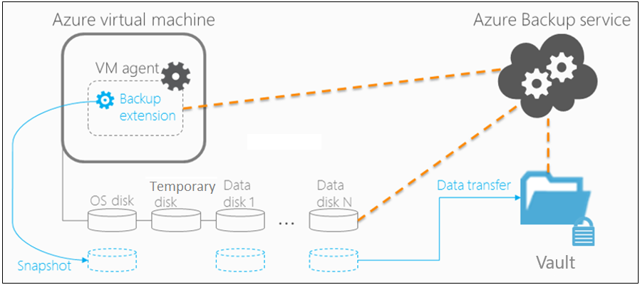

Redundancy
To maintain a high-level of availability across all systems, Bitwarden employs availability zones within Azure. With this in place, it allows users to run the same virtual machine across regions with their own power sources, networking, and cooling. According to Microsoft (https://azure.microsoft.com/en-us/support/legal/sla/virtual-machines/v1_9/), this will guarantee an SLA of 99.99%. More information regarding this can be found in the following documentation from Microsoft: https://docs.microsoft.com/en-us/azure/availability-zones/az-overview
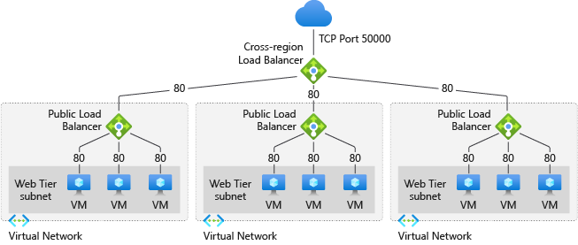

Downtime Procedure
In the event of a downtime, the following steps need to be taken in order to ensure that appropriate actions are taken and communication is clear to employees and customers:
- See if the Downtime is related to any disruptions within Azure via the following methods:
  - Status page: https://status.azure.com/
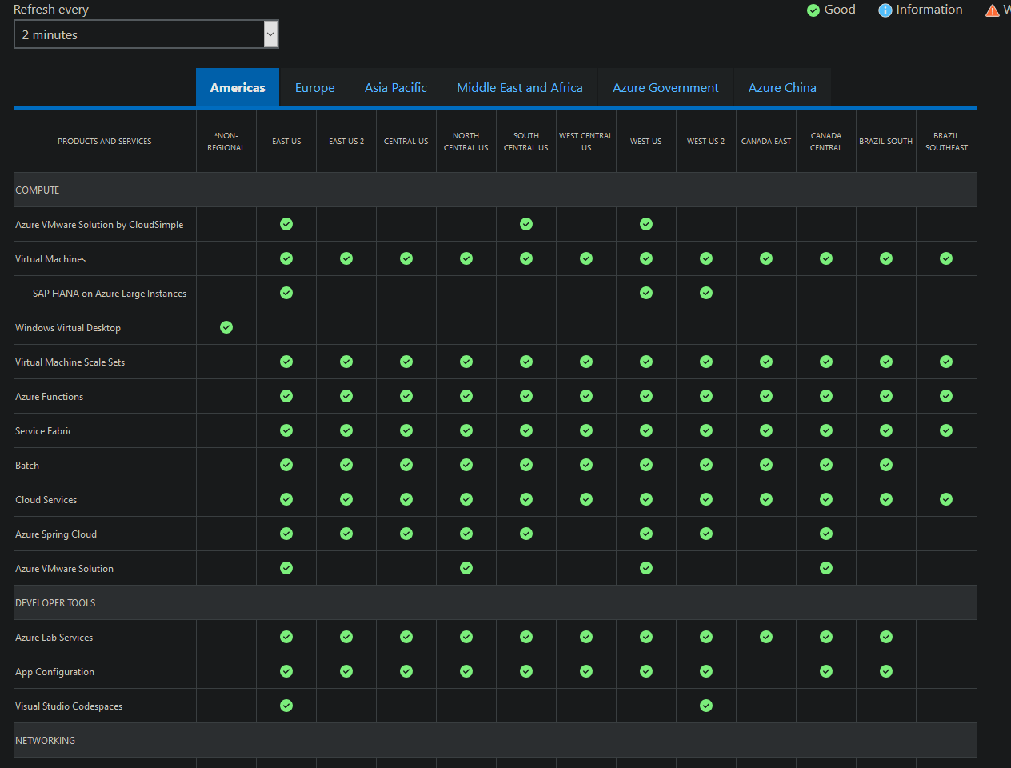
  - Service health page via the Azure Dashboard
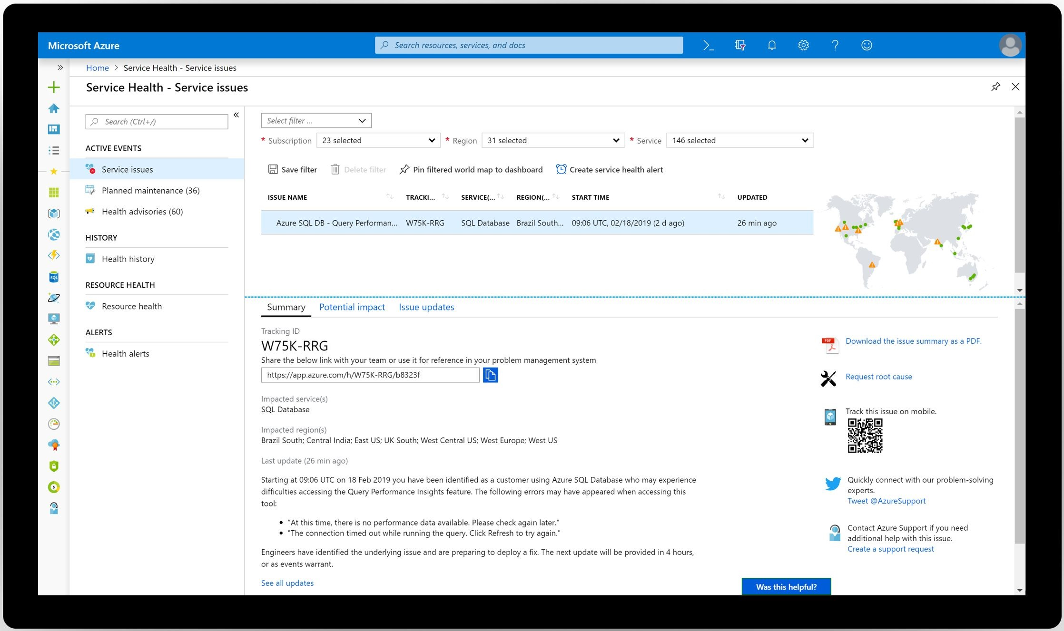
  - Twitter feed: https://twitter.com/MSFT365Status
- If the downtime is due to an issue within Azure, alert Azure’s Rapid Response team of the issue if a support plan of “STANDARD” or above was purchased: https://azure.microsoft.com/en-us/support/plans/response/
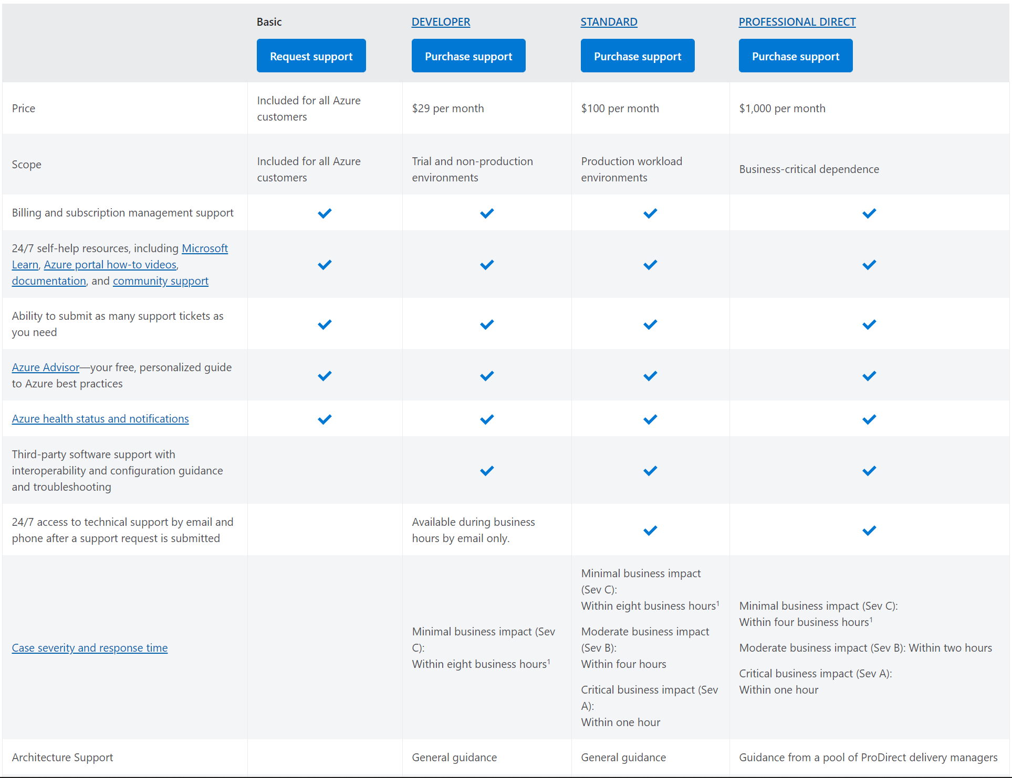
- If the downtime is a result of our own means, notify the appropriate team(s) of the issue and their managers
- Notify all employees via internal communications of the issue and customers via the status.bitwarden.com page -- be sure to keep both parties up-to-date with the most recent information

BC/DR Guide

BC/DR Activation Steps
If an incident is deemed as a disaster, the following items will need to be filled out and kept updated throughout the entire BC/DR phase.

Initial Event Report
Disaster Title:
Timestamp:
Summary:
Assets Affected:
Operations Affected:
Other:

Injury Count: | Death Count:
Cost Estimate:

Checklist
☐ Notified All Appropriate Response Teams | ☐ Notified All Personnel Not Present at the Time of the Disaster
☐ Took All Actions To Ensure the Safety of Personnel near the Disaster | ☐ Initiated Steps to Recover from the Disaster

Disaster Logging
Timestamp | Title/Summary | Actions Taken | Actions Reverted | Cost | Associated Personnel | Approver
3/19/2021 - 21:02 | Example - Video Recorded | Recorded video of all destruction of the fire | None. | None. | Evan Tobler, Mary Rapez | Sebastian Teer

BC/DR Plan Maintenance
Distribution Update Plan
When updates come to the BC/DR plan, all employees will be notified of the changes and where they can access it. These notifications will be sent out via the internal communication platforms of Slack and email. The reason behind why these two platforms are going to be used are due to their ability to notify everyone at once, ensuring that no employee would miss the change log or similar.

BC/DR Plan Change Management Process
For all changes to the BC/DR plan, the initiator must go through the following steps with no exceptions:
- Get approval from their manager and the CISO to start the changes to the plan
- Document all changes and why they were made
- Get at least 5 people from different fields to sign off on the changes that are helpful
- Test all types of scenarios against the new plan which have a correlation to the updates
- Get approval by the CISO and CEO to implement the new change(s)
- Create a backup of the now degraded plan to whatever option was chosen for storage
- Distribute copies of the plan to all employees via Slack and email, along with information on what was changed
- Document everything that was done in a ticket, and get final approval from their manager and CISO to end the process

Reviewing the Plan
Reviewing Bitwarden’s BC/DR plan should be done through the eyes of many people, and slowly and meticulously. It is something to not be taken lightly, as it can become a lifesaver to the company in certain scenarios. Every part of it should be looked at, and when needed, teams brought in to review a part that affects them as well. Additionally, it may be a good idea to get a third-party, professional review of all changes, as an outside view may help spot issues in the plan. This will be done every quarter due to the ever-growing changes within Bitwarden.

Contacts

Response Teams
Due to the operations of Bitwarden all being in the cloud, information was provided for both Bitwarden’s headquarters, along with the nearest Azure Datacenter.
Emergency Response: Bitwarden Headquarters
Santa Barbara Fire Station 2 - 819 Cacique Street, Santa Barbara, CA 93103

City of Santa Barbara Police Department - 215 E Figueroa St, Santa Barbara, CA 93101
Santa Barbara Cottage Hospital - 400 W Pueblo St, Santa Barbara, CA 93105

Emergency Response: Azure Datacenter - West US Region
Sacramento Fire Station #14 - 1341 N C St, Sacramento, CA 95811

Sacramento Police Department - 300 Richards Blvd, Sacramento, CA 95811
Sutter General Hospital - 2825 Capitol Ave, Sacramento, CA 95816
Point of Contact
Fire - 911
Police - 911
Hospital/Ambulance - 911

Insurance Provider
Phone - 800-782-8332
References
1 N Calle Cesar Chavez, Santa Barbara, CA 93103 - Property record | LoopNet.com. (n.d.).
LoopNet: Commercial Real Estate for Sale, Lease, Auction.
https://www.loopnet.com/property/1-n-calle-cesar-chavez-santa-barbara-ca-93103/06083-017113012/
Azure storage blobs pricing. (n.d.). Cloud Computing Services | Microsoft Azure.
https://azure.microsoft.com/en-us/pricing/details/storage/blobs/
Bitwarden. (n.d.). Storage. Retrieved January 29, 2021, from
https://bitwarden.com/help/article/data-storage/#:~:text=information%2C%20see%20Encryption.-,On%20Bitwarden%20Servers,infrastructure%20to%20manage%20and%20maintain.
Cynthn. (2019, October 5). Availability options - Azure virtual machines. Retrieved February 27,
2021, from https://docs.microsoft.com/en-us/azure/virtual-machines/availability
Cynthn. (n.d.). Regions and availability zones in Azure.
https://docs.microsoft.com/en-us/azure/availability-zones/az-overview
Dcurwin. (n.d.). About Azure VM backup - Azure backup. Developer tools, technical
documentation and coding examples | Microsoft Docs. https://docs.microsoft.com/en-us/azure/backup/backup-azure-vms-introduction#backup-process
Dcurwin. (n.d.). What is Azure backup? - Azure backup. Developer tools, technical
documentation and coding examples | Microsoft Docs. https://docs.microsoft.com/en-us/azure/backup/backup-overview
Developer tools, technical documentation and coding examples | Microsoft Docs.
https://docs.microsoft.com/en-us/azure/storage/blobs/storage-blob-storage-tiers
Earthquake hazard maps. (n.d.). FEMA.gov.
https://www.fema.gov/emergency-managers/risk-management/earthquake/hazard-maps
FEMA. (n.d.). [Map]. FEMA.
https://www.fema.gov/sites/default/files/2020-07/fema_hazard_maps_western-map_graphic.jpg
FEMA flood map service center | Search by address. (n.d.).
https://msc.fema.gov/portal/search?AddressQuery=Bitwarden%20Inc.%201%20North%20Calle%20Cesar%20Chavez%20Santa%20Barbara%2C%20CA%2093103%20USA%20#searchresultsanchor
Fire incidents for states and counties. (n.d.). FEMA.gov.
https://www.fema.gov/data-visualization/fire-incidents-states-and-counties
Genesis, W. (2019, September 21). Business contracts attorneys. JGPC Corporate and
Business Law.
https://www.jgpc.com/practice-areas/contracts-transactions/business-contracts-attorneys/
How much does business insurance cost? (n.d.). Progressive Commercial.
https://www.progressivecommercial.com/business-insurance/business-insurance-cost/
Mhopkins-msft. (n.d.). Access tiers for Azure blob storage - hot, cool, and archive.
Developer tools, technical documentation and coding examples | Microsoft Docs. https://docs.microsoft.com/en-us/azure/storage/blobs/storage-blob-storage-tiers
Microsoft. (2020, July). SLA for virtual machines. Retrieved February 27, 2021, from
https://azure.microsoft.com/en-us/support/legal/sla/virtual-machines/v1_9/
Microsoft. (n.d.). Azure blob storage: Microsoft azure. Retrieved February 27, 2021, from
https://azure.microsoft.com/en-us/services/storage/blobs/#overview
Microsoft. (n.d.). Azure service health. Retrieved February 27, 2021, from
https://azure.microsoft.com/en-us/features/service-health/
Microsoft. (n.d.). Choose the Right Azure Region for You: Microsoft Azure. Retrieved January
29, 2021, from https://azure.microsoft.com/en-us/global-infrastructure/geographies/
Msdmaguire. (n.d.). Set up connectors to route mail between Microsoft 365 or office 365 and
your own email servers. Developer tools, technical documentation and coding examples | Microsoft Docs. https://docs.microsoft.com/en-us/exchange/mail-flow-best-practices/use-connectors-to-configure-mail-flow/set-up-connectors-to-route-mail
Msft, M. (2021, January 11). Access tiers for Azure blob storage - hot, cool, and archive.
Retrieved February 27, 2021, from https://docs.microsoft.com/en-us/azure/storage/blobs/storage-blob-storage-tiers
National risk index for natural hazards (NRI). (n.d.). FEMA.gov.
https://www.fema.gov/flood-maps/products-tools/national-risk-index
(n.d.). Status Page - Bitwarden. https://status.bitwarden.com/
Overby, S., & Lynn Greiner and Lauren Gibbons Paul. (n.d.). What is an SLA? Best practices
for service-level agreements. CIO.
https://www.cio.com/article/2438284/outsourcing-sla-definitions-and-solutions.html
Overview of Azure lrs, zrs, grs - Ra GRS. (n.d.). C# Corner - Community of Software and
Data Developers. https://www.c-sharpcorner.com/article/overview-of-azure-lrs-zrs-grs-ra-grs/#:~:text=%20What%20is%20Azure%20LRS,%20ZRS%20GRS%20%E2%80%93,the%20different%20services%20coming%20under%20the...%20More
Prsandhu. (2021, February 23). Regions and availability zones in Azure. Retrieved February 27,
2021, from https://docs.microsoft.com/en-us/azure/availability-zones/az-overview
Snedaker, S., & Rima, C. (2014). Business continuity and disaster recovery planning for IT
professionals (2nd ed.)
Spark, W. (n.d.). WeatherSpark.com. Retrieved January 29, 2021, from
https://weatherspark.com/y/1482/Average-Weather-in-Fresno-California-United-States-Year-Round
Tamram. (n.d.). Storage account overview. Developer tools, technical documentation and
coding examples | Microsoft Docs. https://docs.microsoft.com/en-us/azure/storage/common/storage-account-overview
Lucco, J. (2020, October 22). Time to conduct a strategy review? Here's how to get started.
Retrieved April 07, 2021, from https://www.clearpointstrategy.com/strategy-review-process/

